**Analysis using Correlation Coefficient Graph:**

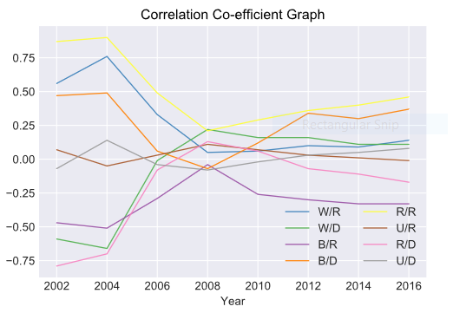

Table 1.1 Correlation Coefficient values for Maryland State:

|  |  |  |  |  |  |  |  |  |
| --- | --- | --- | --- | --- | --- | --- | --- | --- |
| Year | W/R | W/D | B/R | B/D | R/R | U/R | R/D | U/D |
| 2002 | 0.56 | -0.59 | -0.47 | 0.47 | 0.87 | 0.07 | -0.79 | -0.07 |
| 2004 | 0.76 | -0.66 | -0.51 | 0.49 | 0.9 | -0.05 | -0.7 | 0.14 |
| 2006 | 0.33 | -0.01 | -0.29 | 0.06 | 0.49 | 0.03 | -0.08 | -0.04 |
| 2008 | 0.05 | 0.22 | -0.04 | -0.07 | 0.21 | 0.11 | 0.13 | -0.08 |
| 2010 | 0.06 | 0.16 | -0.26 | 0.12 | 0.29 | 0.07 | 0.06 | -0.02 |
| 2012 | 0.1 | 0.16 | -0.3 | 0.34 | 0.36 | 0.03 | -0.07 | 0.03 |
| 2014 | 0.09 | 0.11 | -0.33 | 0.3 | 0.4 | 0.01 | -0.11 | 0.05 |
| 2016 | 0.14 | 0.11 | -0.33 | 0.37 | 0.46 | -0.01 | -0.17 | 0.08 |

The Correlation Co-efficient graph has been plotted for Maryland State to see the statistical relationship between the factors.

For 2002 year, the Rural Area vs Republic votes has the highest co-efficient value which is 0.87. However, the value has gradually decreased to 0.21 till the year 2008 which is showing a negative correlation. However, from the year 2008 to 2016, it has increased by 0.25

From Rural area vs Democratic votes graph, it has clearly seen that the value has been drastically increased from year 2002 to 2008 from -0.79 to 0.13 and again decreased to -0.07 in 2016 year.

In Urban area vs Republic votes graph, after a minute drop in the 2004 year, the value suddenly rose to 0.11 from -0.05 in 2008 year. However, it fell to -0.01 in 2016 year showing a negative correlation.

In Urban area vs Democratic votes graph, the graph fluttered during the period of 2002 to 2008 as the values are fluctuating between -0.07 to 0.14. From 2008 year, the graph went up from -0.02 to 0.08.

From year 2004 to 2012, the graph of Black population vs Republic votes, the coefficient value grew from -0.51 to -0.3. Although, it dropped to -0.33 in the year 2016.

From year 2002 to 2008, the graph of Black population vs Democratic votes, the value declined toward negative correlation. But, later in the period of 2008 to 2016 it went up to 0.11 from -0.07 showing positive correlation.

In White population vs Republic votes graph, the graph is implied more towards negative correlation as the value fell to 0.05 from 0.76 from year 2004 to 2008. However, it shows positive correlation from year 2008 to 2016 where the value grew to 0.14.

In White population vs Democratic votes graph, the graph is inclined towards positive correlation from year 2002 to 2008 i.e. -0.59 to 0.22. Eventually, the value goes down to 0.11 in the year 2016.